BRIEF INFO ABOUT OUR PROJECT
With this project we aim to:
- improve the skills, competences and methodology of the VET schools staff that is involved in the practical training of cooks and waiters;
- to strengthen key competences in VET curricula and provide more effective opportunities;
- to acquire or develop those skills through relevant competencies and valuable knowledge, skills and attitudes for the labor market of tourism;
- to enhance the access to training and qualifications for all, in a life-long learning perspective, especially by raising awareness on the cook and waiter careers in Europe;
- to improve transparency and recognition of skills and qualifications, by comparing different European training curricula and developing two new courses, both with traditional and online structure.

At the same time, during the implementation period we will focus on:
- Training Need Analysis of the school staff that works with cooks/waiters training, in close cooperation with the employers;
- Comprehensive Guidebook for waiters and cooks, based on the Training Need Analysis;
- Recommendation paper for improvement of existing profiles cook and waiter in each country.

Target group of the project are:
Direct target groups would be staff of VET schools for Hospitality and Tourism that works in the practical training of cooks and waiters. Indirect target group are their students that come mainly from areas with tourism potential and has less access to possibilities for modern training. This will be the population of young people, who are in the last year of their education or recently finished secondary school but have difficulties to find job in the hospitality industry as cooks or waiters. Within the framework of this project those trained staff will work with young people and are expected to increase their professional skills but also their soft skills like communication skills, their initiative, adaptability, self-management techniques, but also their inter-cultural awareness.

PROJECT PARTNERS
The project partners come from Ohrid, Macedonia and Madrid, Spain.

OUTU "Vanco Pitosheski" is secondary school of tourism and catering. The school is founded in 1960. The activity of this school is education of vocational duties in the field of tourism and catering.
Our high-school took active participation in the realization of the project "tour.reg", which is financed by the Government of Republic of Austria in coordination of Ministry of education and culture of Republic of Macedonia. There were the Austrian experts who were doing the vocational training to our teachers, but also our teachers visited some vocational schools in Austria with the only aim – exchanging mutual ideas and experiences about the process of working between the schools.

There are 5 profiles of students in our school
- Waiter
- Cook
- Receptionist
- Catering receptionist
- Catering receptionist of rural tourism
There are 33 teachers, from which 12 of them are vocational teachers. Each of them has certain qualifications, skills and experiences from their profession.
ADEFIS was established as a non-profit organization in order to promote equality and integration among young people, developing projects and programs aimed at preventing discrimination for any reason: birth, race, sex, religion or personal and social status, as stated in the Spanish Constitution; as well as in the implementation of projects and programs for the protection of the environment, sustainable development, culture, promotion of volunteering and awareness to the Spanish, European and third-countries. Also, to promote cooperation development and co-development in countries with low per capita income and extreme poverty.
It specializes in personal and professional development through socio-educational methods based on non-formal education, both at European and regional levels. It is highly qualified in the social field and extensive experience in the computer industry. Its headquarters has two premises located at street level in downtown Las Rozas and part of the rent is subsidized by the City-Hall of Las Rozas.

TRANSNATIONAL PROJECT MEETING IN OHRID, MACEDONIA

During the dates 18 – 21 January 2018 we organised the first transnational project meeting. It was held in Ohrid, Macedonia and it took place in the premices of the Partners School OUTU Vanco Pitoseski. Representatives from all tree partners from Serbia, Macedonia and Spain were present and we utilised this opportunity to scrutinise all relevant aspects related to the upcoming tasks and steps in the implementation of our project.
The meeting was useful as the partners had the possibility to discuss in one place all of the detailed future steps for implementation, including the Intellectual Output, Training Event in Madrid and even basic aspects of the Multiplier even that is to be implemented later in the course of the year.

The activity structure of the project was elaborated to all partners even prior to their arrival to Macedonia. Also, during this meeting more concretely tasks related to the development of the Intellectual output were distributed and we focused also on the structure of the output as well as the planned impact it should have over the targeted audience.

At the same time, other aspects were covered such as administrative and financial items.

The hosts from Macedonia made sure to present to us the beauty of the old City of Ohrid and also organised a well-structured and fruitful working sessions and meetings.

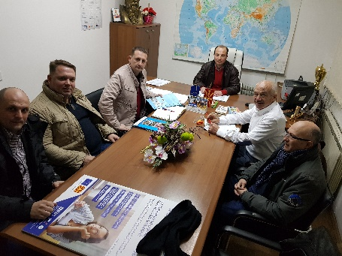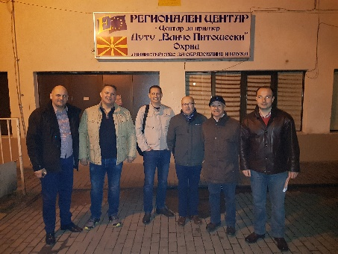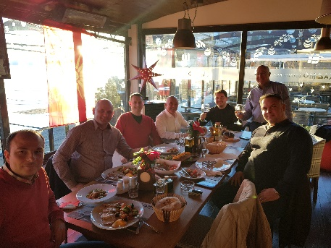

LEARNING/TEACHING/TRAINING EVENT IN MADRID, SPAIN

The training activity was addressed to provide teachers with new methodologies to develop transferable competences among their students. The competences have been identified in other various initiatives with a similar topic. Concretely the methodology the staff learned was collaborative learning in the context of VET. This methodology enables the development of key competencies such as conflict management, team work, communication and intercultural sensitization.

The programme was displayed along 5 days and it included the following activities:
- Introduction to the programme and to the context of the Spanish VET system;
- Training session to the introduction of cooperative learning;
- Job shadowing in a class where cooperative learning is applied;
- Job shadowing on entrepreneurial skills;
- Training session on career guidance: networking, tools for the accreditation of competences, new formats of CV.

During the stay in Madrid teachers from Serbia and Macedonia had the possibility to visit 5 different VET school in Madrid (of the hospitality/tourism/catering vocation) where they saw in first hand the manner in which Vocational education and training is conducted in one of the 3 worlds best and most popular tourist destinations.

